Self Assessment Report

# Grade: XX

<Please grade your group score here /10 points, honestly>

# Group XX

<Please replace XX with your group ID>

|  |  |  |
| --- | --- | --- |
| >Student ID | Full Name | Github Username |
|  |  |  |
|  |  |  |
|  |  |  |
|  |  |  |

# Contributions

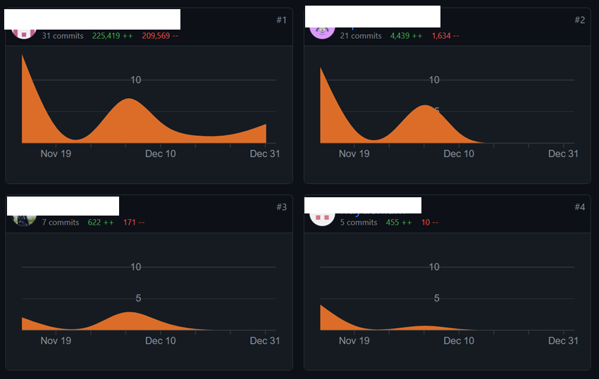

<Please replace the this photo with your team github contribution page>

|  |  |  |
| --- | --- | --- |
| Student ID | Number of Commits | Contribution (total 100%) |
|  | 31 | 25% |
|  | 21 | 25% |
|  | 7 | 25% |
|  | 5 | 25% |

# Sample screenshot

<Screenshot of <https://drive.google.com/file/d/1St_8CSQmrTAkyo0XFWIGkDRiUpxhxUxK/view?usp=drive_link>>

# Show case screenshot

<Screenshot of <https://drive.google.com/drive/folders/1hSOCsf1_E_yu7IPLExYMvW_IgJqSo-Mh?usp=drive_link>>

# Milestone 3 screenshot

<Screenshot of <https://docs.google.com/spreadsheets/d/1Lbu5Uxfa29mZKw3peOk103NCOLNxoolN-55yhKZ5z8s/edit?usp=drive_link>>

# Optional features

<Please describe those features and screenshot/video link for demonstration>

## Zoom in/out

## Interactive

## Radical Gradient

## …